**Web-based Ordering & Ingredient Estimating for Bakery Manufacturer**

Software Requirement Specification

By

**Miss. Nontra Mahachanont 542115026**

**Mr. Parinya Panyanak 542115034**

Department of Software Engineering

College of Arts, Media and Technology

Chiang Mai University

Project Advisor

________________________

**Mr.Phudinan Singkhamfu**

|  |  |  |
| --- | --- | --- |
| **Software Requirement Specification** | | |
| Cross Ref. VSE-29110 | **Coverage Level:** | **Version:** |
|  | V.2.0 | V.2.0 |

|  |  |
| --- | --- |
| **Process Ownership** | **Approving Authority** |
| Web-based Ordering & Ingredient Estimating for Bakery Manufacturer | Aj.Phudinan Singkhamfu |
| **Scope** | **Approved Date** |
| Senior Project | 20 October 2014 |

|  |  |  |  |  |
| --- | --- | --- | --- | --- |
| **Version Number** | **Record Date** | **Prepared/**  **Modified By** | **Reviewed By** | **Change Details** |
| **Documents History** | | | | |
| V.1.1 | 06-09-2014 | NM, PP | NM, PP | - Add Product Features #3 and #4  - Add Operation Environment |
| V.1.3 | 07-09-2014 | NM, PP | NM, PP | - Add User Requirements Feature #3 and #4  - Add Chapter 4  - Fix inappropriate words |
| V.1.5 | 09-09-2014 | NM, PP | NM, PP | - Adjust Chapter 4  - Add Chapter 5  - Fix inappropriate words |
| V.1.6 | 12-09-2014 | NM, PP | NM, PP | - Adjust Chapter 4  - Adjust Use case Scenarios  - Fix inappropriate words |
| V.1.7 | 14-09-2014 | NM, PP | NM, PP | - Adjust SRS |
| V.2.0 | 17-09-2014 | NM, PP | NM, PP | - Add Use Case Description  - Add Use Case Specification  - Adjust Chapter 3  - Adjust Chapter 4  - Adjust Use Case Diagram  - Adjust Activity Diagram  - Fix inappropriate words |

**\*NM = Nontra Mahachanont**

**\*PP = Parinya Panyanak**

**\*PS = Phudinan Singkhamfu**

**Table of contents**

**Chapter One | Introduction** 4

1.1 Objective 4

1.2 Intended Audience and Reading Suggestions 4

1.3 Project Scope 4

**Chapter Two | Overall Description** 5

2.1 Product Perspective 5

2.2 Product Features 5

2.3 User Classes and Characteristics 5

2.4 Operation Environment 5

2.5 Design and Implementation Constraints 6

**Chapter Three | User Requirements** 7

**Chapter Four | System Features** 8

4.1 Software Requirement Specification 8

**Chapter Five | Specific Requirement** 15

5.1 Use Case Scenarios 15

5.2 Use Case Description 16

5.3 Use Case Specification 24

# **Chapter One | Introduction**

## 1.1 Objective

* To help manufacturer estimate ingredients and control usage.
* To support the manufacturer can cooperation.
* To control document of the manufacturer easily.
* To support wholesaler ordering conveniently.

## 1.2 Intended Audience and Reading Suggestions

This Software Requirement Specification was created for everyone that involves with the Web-based Ordering & Ingredient Estimating for Bakery Manufacturer. It will make benefits for people as following

**Development Team**

**-** Convenient to make strategies and planning process.

**-** Control and guarantee qualities of the system to make it right according to the standard.

**-** Check the customer requirement for makes sure that everyone has the same understand and avoid the fault of the work.

**-** In testing system, tester will verify the system work correctly without any problem.

**Customer**

**-** Help customer to understand about quality and limitation of this system.

**-** Checking the requirement of the customer and the system are the same.

## 1.3 Project Scope

Web-based Ordering & Ingredient Estimating for Bakery Manufacturer is a management system that helps the admin to manage ordering information and estimate ingredient usage. Then the system also helps the wholesaler to manage order and record ordered history. The project focuses on implementation of general order management system.

# **Chapter Two | Overall Description**

## Product Perspective

Web-based Ordering & Ingredient Estimating for Bakery Manufacturer has two main sections which are Admin section and Wholesaler section. This system can help admin and wholesaler for convenient to order bakery product and check ordered information. System can help for keeping ordered history and make a summary report.

## Product Features

Main features of Web-based Ordering & Ingredients Estimating for Bakery Manufacturer will be following

**Feature 3: Order Management System**

* Order feature
* Ordered information page
* Search order information
* Order notification page
* Mark progressive of order status while the order in preparation stage
* Progress order status information while the order in preparation stage

**Feature 4: Ingredient Management System**

* Manage ingredient information
* Search ingredient information
* Ingredient information page

## 2.3 User Classes and Characteristics

Intended users for this project are people of admin permission to make an order of bakery product and officer that can involve knowing information.

## 2.4 Operation Environment

Firefox Version 32.0 or Later

## 2.5 Design and Implementation Constraints

**Design**

Provide web application for easy to use. Design for easy to understand. The user who not have skill able to buy bakery product from the website.

**Constraints**

- Only member can access the web application.

- Require internet connection.

# **Chapter Three | User Requirements**

* **URS-07:** Wholesaler can order bakery products from the product list. An order can

select by input bakery product name, bakery product quantity and delivery date.

* **URS-08:** Wholesaler can manage own order information; bakery product

name, bakery product quantity and delivery date in the order page.

* **URS-09:** Wholesaler can view their current order’s information; all list of bakery

product name, bakery product quantity, price of each bakery product, the total price and discount of the order.

* **URS-10:** Admin can view current order’s information of all members by search

keyword of wholesaler name, bakery product ID, bakery product name and delivery date in the database.

* **URS-11:** Admin can mark progressive of order status while the order in the

preparation stage.

* **URS-12:** Wholesaler can view their progress order status while the order in the

preparation stage.

* **URS-13:** Admin can manage all ingredient information; ingredient ID, ingredient

name, category and ingredient picture in the database.

* **URS-14:** Admin can view all ingredient information by search keyword of

ingredient ID, ingredient name category and category in the database.

# 

# **Chapter Four | System Features**

## Software Requirement Specification

**URS-07:** Wholesaler can order bakery products from the product list. An order can select by input bakery product name, bakery product quantity and delivery date.

**SRS-38:** The system can connect to the phungnoi database and access User, webpages_Roles, Product, Order and OrderDetail tables.

**SRS-28:** The system shall provide a textbox in bakery product interface to search the bakery product information; bakery product ID, bakery product name, price and category in the database.

**SRS-39:** The system shall provide service for validation input information; bakery product ID, bakery product name, price and category with the existing bakery product information in the database.

**SRS-29:** The system shall provide a user interface to display all bakery product list. In each label shall display bakery product name text and bakery product picture on bakery product list.

**SRS-30:** The system shall provide a user interface to display the existing bakery product information which are bakery product ID, bakery product name, product description, product price, product category and product picture on view information of bakery product page.

**SRS-40:** The system shall provide a link for ordering in the order product interface.

**SRS-41:** The system shall provide an order form in order product page for wholesaler input name of the bakery product, bakery product quantity and delivery date.

**SRS-42:** The system shall generate other information from input bakery name consist of bakery product ID, product price and product picture in each label of product list.

**SRS-43:** The system shall provide a calculating function to compute the total price and discount of each order.

**SRS-44:** The system shall provide a user interface to display the result of the total price and discount from all bakery product list.

**SRS-45:** The system shall provide button for sending finished order information in the order product interface.

**SRS-46:** The system shall provide button for repeating previous order information in the order history interface.

**SRS-47:** The system shall provide a user interface to display all list of the delivery date from previous order information. In each label shall display delivery date and total price on the order history list.

**SRS-48:** The system shall provide confirmation dialog box after delivery date link has been chosen.

**SRS-49:** The system shall provide a message to display a notification after the order form has been sent.

**SRS-50:** The system shall provide a link for saving unfinished product list in order product interface.

**SRS-06:** The system shall provide service to store information into the database.

**URS-08:** Wholesaler can manage own order information; bakery product name, bakery product quantity and delivery date in the order management page.

**SRS-38:** The system can connect to the phungnoi database and access User, webpages_Roles, Product, Order and OrderDetail tables.

**SRS-28:** The system shall provide a textbox in bakery product interface to search the bakery product information; bakery product ID, bakery product name, price and category in the database.

**SRS-39:** The system shall provide service for validation input information; bakery product ID, bakery product name, price and category with the existing bakery product information in the database.

**SRS-29:** The system shall provide a user interface to display all bakery product list. In each label shall display bakery product name text and bakery product picture on bakery product list.

**SRS-30:** The system shall provide a user interface to display the existing bakery product information which are bakery product ID, bakery product name, product description, product price, product category and product picture on view information of bakery product page.

**SRS-51:** The system shall provide a user interface to display current order’s information which are wholesaler name, bakery product ID, bakery product name, bakery product quantity and delivery date on view information of order management page.

**SRS-52:** The system shall provide a link for updating current order’s information in the order management interface.

**SRS-53:** The system shall provide an update form in order product page for wholesaler input name of the bakery product, bakery product quantity and delivery date.

**SRS-42:** The system shall generate other information from input bakery name consist of bakery product ID, product price and product picture in each label of product list.

**SRS-43:** The system shall provide a calculating function to compute the total price and discount of each order.

**SRS-44:** The system shall provide a user interface to display the result of the total price and discount from all bakery product list on view information of order management page.

**SRS-45:** The system shall provide button for sending finished order information in the order management interface.

**SRS-49:** The system shall provide a message to display a notification after the order form has been sent.

**SRS-54:** The system shall provide service to update order information into the database.

**SRS-55:** The system shall provide a link for deleting bakery product from order information in the order management interface.

**SRS-56:** The system shall provide confirmation dialog box after confirmation button has been chosen.

**SRS-57:** The system shall provide service to cancel order information into the database.

**SRS-58:** The system shall provide a message to display a notification after the order information has been deleted.

**URS-09:** Wholesaler can view their current order’s information; all list of bakery product name, bakery product quantity, price of each bakery product, the total price and discount of the order.

**SRS-59:** The system can connect to the phungnoi database and access User, webpages_Roles and OrderDetail tables.

**SRS-60:** The system shall provide a link for view current order’s information in the view order information interface.

**SRS-52:** The system shall provide a user interface to display current order’s information which are wholesaler name, bakery product ID, bakery product name, bakery product quantity and delivery date on view information of order page.

**SRS-44:** The system shall provide a user interface to display the result of the total price and discount from all bakery product list on view information of order page.

**URS-10:** Admin can view current order’s information of all members by search keyword of wholesaler name, bakery product ID, bakery product name and delivery date in the database.

**SRS-59:** The system can connect to the phungnoi database and access User, webpages_Roles and OrderDetail tables.

**SRS-61:** The system shall provide a textbox in order management interface to search the order information; wholesaler ID, wholesaler name, bakery product ID, bakery product name and delivery date.

**SRS-62:** The system shall provide service for validation input information; wholesaler ID, wholesaler name, bakery product ID, bakery product name and delivery date with the existing order information in the database.

**SRS-63:** The system shall provide a user interface to display a list of all wholesaler who has current order’s information. In each label shall display wholesaler name text and delivery date on order information list.

**SRS-49:** The system shall provide a user interface to display the existing order information which are customer name, bakery product ID, bakery product name, amount of each bakery product and delivery date on view information of order page.

**URS-11:** Admin can mark progressive of order status while the order in the preparation stage.

**SRS-59:** The system can connect to the phungnoi database and access User, webpages_Roles and OrderDetail tables.

**SRS-61:** The system shall provide a textbox in order management interface to search the order information; wholesaler ID, wholesaler name, bakery product ID, bakery product name and delivery date.

**SRS-62:** The system shall provide service for validation input information; wholesaler ID, wholesaler name, bakery product ID, bakery product name and delivery date with the existing order information in the database.

**SRS-63:** The system shall provide a user interface to display a list of all wholesaler who has current order’s information. In each label shall display wholesaler name text and delivery date on order information list.

**SRS-64:** The system shall provide button for marking progressive of order status in the order management interface.

**SRS-56:** The system shall provide confirmation dialog box after confirmation button has been chosen.

**SRS-65:** The system shall provide a message to display a notification after the order status in the preparation stage has been marked.

**SRS-06:** The system shall provide service to store information into the database.

**SRS-66:** The system shall provide service to update progressive of order status to display in order management interface.

**URS-12:** Wholesaler can view their progress status while the order in the preparation stage.

**SRS-59:** The system can connect to the phungnoi database and access User, webpages_Roles and OrderDetail tables.

**SRS-51:** The system shall provide a user interface to display current order information which are wholesaler name, bakery product ID, bakery product name, bakery product quantity and delivery date on view information of order page.

**SRS-67:** The system shall provide a text to display the order status in their order page.

**URS-13:** Admin can manage all ingredient information; ingredient ID, ingredient name, category and ingredient picture in the database.

**SRS-68:** The system can connect to the phungnoi database and access User, webpages_Roles and Ingredient tables.

**SRS-69:** The system shall provide a link for creating new ingredient information in the ingredient interface.

**SRS-70:** The system shall provide an ingredient form in a create new ingredient information page for an admin input ingredient ID, ingredient name, category and ingredient picture.

**SRS-71:** The system shall provide service for validation input information; ingredient ID, ingredient name, category and ingredient picture.

**SRS-72:** The system shall provide a message to display a notification after the ingredient form has been sent.

**SRS-06:** The system shall provide service to store information into the database.

**SRS-73:** The system shall provide a textbox in ingredient interface to search the ingredient information; ingredient ID, ingredient name and category.

**SRS-74:** The system shall provide service for validation input information; ingredient ID, ingredient name and category with the existing ingredient information in the database.

**SRS-75:** The system shall provide a user interface to display all list of ingredient. In each label shall display ingredient name text and ingredient picture on an ingredient list.

**SRS-76:** The system shall provide a user interface to display the existing ingredient information which are ingredient ID, ingredient name, category and ingredient picture on view information of ingredient page.

**SRS-77:** The system shall provide a link for updating ingredient information in the ingredient interface.

**SRS-78:** The system shall provide an ingredient form in update ingredient information page for admin update new ingredient ID, ingredient name, category and ingredient picture.

**SRS-79:** The system shall provide service to update ingredient information into the database.

**SRS-80:** The system shall provide a link for deleting ingredient information in the ingredient interface.

**SRS-56:** The system shall provide confirmation dialog box after confirmation button has been chosen.

**SRS-81:** The system shall provide service to delete ingredient information into the database

**SRS-82:** The system shall provide a message to display a notification after the ingredient information has been deleted.

**URS-14:** Admin can view all ingredient information by search keyword of ingredient ID, ingredient name and category in the database.

**SRS-68:** The system can connect to the phungnoi database and access User, webpages_Roles and Ingredient tables.

**SRS-73:** The system shall provide a textbox in ingredient interface to search the ingredient information; ingredient ID, ingredient name and category.

**SRS-74:** The system shall provide service for validation input information; ingredient ID, ingredient name and category with the existing ingredient information in the database.

**SRS-75:** The system shall provide a user interface to display all list of ingredient. In each label shall display ingredient name text and ingredient picture on an ingredient list.

**SRS-76:** The system shall provide a user interface to display the existing ingredient information which are ingredient ID, ingredient name, category and ingredient picture on view information of ingredient page.

# **Chapter Five | Specific Requirement**

## D:\NEST Work\Senior Project\Progress Report II\Diagram\Use Case Diagram II.jpg5.1 Use Case Scenarios

**Figure 1: Use case diagram that show activity of Admin and Wholesaler**

## 

## 5.2 Use Case Description

**User Case:** Order Bakery Product

|  |  |
| --- | --- |
| **Use Case ID:** | UC – 07 |
| **Use Case Name:** | Order Bakery Product |
| **Actors:** | Wholesaler |
| **Short Description:** | This use case allows wholesaler can order bakery products by adding updating and removing bakery product name, bakery product quantity and delivery date to their product list. |
| **Preconditions:** | Wholesaler has login to the website. |
| **Postconditions:** | Wholesaler can send order request of bakery product into the database. |
| **Normal Flow:** | 1. Request an order link in order product page.  2. Select “New order” or “Repeat order information” button functions.  3. Input new order information (bakery product name, bakery product quantity and delivery date of order) into order form.  4. System shall display a calculation of bakery product list, discount and total price of the order.  5. Select “Save unfinished” or “Send order” button functions.  6. System shall collect order information to the database.  7. System shall display successful order message. |
| **Alternative and Exceptional:** | 2a. In step 2 of the normal flow.  If the wholesaler selects, a new order of bakery product.  2.1 Use case resume on step 3 of normal flow.  2b. In step 2 of the normal flow.  If the wholesaler selects, repeat order information.  2.1 System shall request all previous order list from the system.  2.2 Select one label from previous delivery date.  2.3 Use case resume on step 4 of normal flow.  3a. In step 3 of the normal flow.  If the admin input invalid information type.  3.1 System displays an error message to admin.  3.2 System shall request the command from admin to input again.  3b. In step 3 of the normal flow.  If the admin input valid information type.  3.1 Use case resumes on step 4 of normal flow.  5a. In step 5 of the normal flow.  If the wholesaler selects, save unfinished bakery product list.  5.1 System shall save unfinished bakery product list information.  5.2 Use case resume on step 7 of normal flow.  5b. In step 5 of the normal flow.  If the wholesaler selects, send order information.  5.1 System shall validates conditional of time before midday.  5.2 Decide to send order information.  5.3 Use case resume on step 6 of normal flow. |

**User Case:** Manage own Order Information

|  |  |
| --- | --- |
| **Use Case ID:** | UC – 08 |
| **Use Case Name:** | Manage own Order Information |
| **Actors:** | Wholesaler |
| **Short Description:** | This use case allows wholesaler manage own order information by editing and deleting order information in the system. |
| **Preconditions:** | Wholesaler has login to the website and order information has been sent to the database. |
| **Postconditions:** | Wholesaler can update and cancel own order information. Then recent order information updating into the database. |
| **Normal Flow:** | 1. Request order management page.  2. System shall display current order’s information; bakery product list, bakery product quantity, discount and total price of the order.  3. Select “Update” or “Cancel” order information functions.  4. Input update order information (bakery product name, bakery product quantity and delivery date of order) into order form.  5. System shall display update calculation of bakery product list, discount and total price of the order.  6. Click “Send order” button function.  7. System shall send update order information to the database.  8. System shall display successful updated order information to the system. |
| **Alternative and Exceptional:** | 3a. In step 3 of the normal flow.  If the wholesaler selects, update own order information.  3.1 Use case resume on step 4 of normal flow.  3b. In step 3 of the normal flow.  If the wholesaler selects, cancel order information.  3.1 System shall validates conditional of time before midday.  3.2 Accept conditional to cannot cancel order information.  3.3 Use case resume on step 7 of normal flow.  4a. In step 4 of the normal flow.  If the admin input invalid information type.  4.1 System displays an error message to admin.  4.2 System shall request the command from admin to input again.  4b. In step 4 of the normal flow.  If the admin input valid information type.  4.1 Use case resumes on step 5 of normal flow.  6a. In step 6 of the normal flow.  If the updated order invalid with the conditional of time before midday.  6.1 System displays the conditional message to wholesaler.  6.2 System shall request confirmation from wholesaler.  6b. In step 6 of the normal flow.  If the updated order valid with the conditional of time before midday.  6.1 Use case resume on step 7 of normal flow. |

**User Case:** View Order Information

|  |  |
| --- | --- |
| **Use Case ID:** | UC – 09 |
| **Use Case Name:** | View Order Information |
| **Actors:** | Admin and Wholesaler |
| **Short Description:** | This use case allows admin and wholesaler can view current order’s information in the system. |
| **Preconditions:** | Admin and Wholesaler have login to the website. |
| **Postconditions:** | Admin and Wholesaler can know order information from the database. |
| **Normal Flow:** | 1. Request order management page.  2. Search a keyword to retrieve order information from the database.  3. System shall validation keyword with the database.  4. System shall display the existing order list has been matched.  5. Select a label from the existing order list information.  6. System shall display order information from the database. |
| **Alternative and Exceptional:** | 3a. In step 3 of the normal flow.  If the input valid with information in the database.  3.1 Use case resume on step 4 of normal flow.  3b. In step 3 of the normal flow.  If the input invalid with information in the database.  3.1 System displays the not found message to the user.  3.2 System shall request the new command from admin and wholesaler to input again.  4a. In step 4 of the normal flow.  If the admin select one label from the existing order list.  4.1 Use case resume on step 5 of normal flow.  4b. In step 4 of the normal flow.  If the admin select order management bar from the main menu.  4.1 System shall return to the order management page. |

**User Case:** Mark order status

|  |  |
| --- | --- |
| **Use Case ID:** | UC – 10 |
| **Use Case Name:** | Mark Order Status |
| **Actors:** | Admin |
| **Short Description:** | This use case allows admin can mark all progressive of order status while the order in the preparation stage. |
| **Preconditions:** | Admin has login to the website. |
| **Postconditions:** | Admin can mark order status into the database. |
| **Normal Flow:** | 1. Request order management page.  2. Search the order information in the web application.  3. System shall validation keyword from the database.  4. System shall display the existing order list has been matched.  5. Select a label from order list to display order information.  6. Click “Available” button.  7. System shall send update order status information to the database.  8. System shall display successful message to update order status when the order finished preparation stage. |
| **Alternative and Exceptional:** | 3a. In step 3 of the normal flow.  If the input valid with information in the database.  3.1 Use case resume on step 4 of normal flow.  3b. In step 3 of the normal flow.  If the input invalid with information in the database.  3.1 System displays the not found message to the admin.  3.2 System shall request the command from the admin to input again.  4a. In step 4 of the normal flow.  If the admin select one label from the existing order list.  4.1 Use case resume on step 5 of normal flow.  4b. In step 4 of the normal flow.  If the admin select order management bar from the main menu.  4.1 System shall return to the order management page. |

**User Case:** View Order Status

|  |  |
| --- | --- |
| **Use Case ID:** | UC – 11 |
| **Use Case Name:** | View Order Status |
| **Actors:** | Wholesaler |
| **Short Description:** | This use case allows wholesaler can view their progress order status while the order in the preparation stage. |
| **Preconditions:** | Wholesaler has login to the website and order information has been submitted. |
| **Postconditions:** | Wholesaler can know their order status from the database. |
| **Normal Flow:** | 1. Request order product page.  2. System shall display current order’s list in the database.  3. System shall display order status at the end of each current order’s list. |
| **Alternative and Exceptional:** | 3a. In step 3 of the normal flow.  If the order status incomplete.  3.1 System displays the unavailable message to wholesaler.  3b. In step 3 of the normal flow.  If the order status completed.  3.1 System displays the available message to wholesaler. |

**User Case:** Manage Ingredient Information

|  |  |
| --- | --- |
| **Use Case ID:** | UC – 12 |
| **Use Case Name:** | Manage Ingredient Information |
| **Actors:** | Admin |
| **Short Description:** | This use case allows admin can manage all ingredient information. The admin can add, update and delete ingredient information in the system. |
| **Preconditions:** | Admin has login to the website. |
| **Postconditions:** | Admin can manage all ingredient information and save new information into the database. |
| **Normal Flow:** | 1. Request ingredient management page.  2. Search the ingredient information in the web application.  3. System shall validation keyword from the database.  4. System shall request the existing ingredient list from the database.  5. Select a label from all ingredient list to display ingredient information.  6. Select “create”, “update” or “delete” ingredient information functions.  7. Input ingredient information (Ingredient ID, ingredient name, category and ingredient picture) into the ingredient form.  8. System shall validation input information.  9. Click “Save” button.  10. System shall collect new information to the database.  11. System shall display successful message to the admin. |
| **Alternative and Exceptional:** | 3a. In step 3 of the normal flow.  If the input invalid with information in the database.  3.1 System displays the not found message to the admin.  3.2 System shall request the command from admin to input again.  3b. In step 3 of the normal flow.  If the input valid with information in the database.  3.1 Use case resume on step 4 of normal flow.  6a. In step 6 of the normal flow.  If the admin clicks, create new ingredient information.  6.1 Use case resume on step 7 of normal flow.  6b. In step 6 of the normal flow.  If the admin clicks, update ingredient information.  6.1 Use case resume on step 7 of normal flow.  6c. In step 6 of the normal flow.  If the admin clicks, delete ingredient.  5.1 Use case resume on step 9 of normal flow.  8a. In step 8 of the normal flow.  If the admin input invalid information type.  8.1 System displays an error message to admin.  8.2 System shall request the command from admin to input again.  8b. In step 8 of the normal flow.  If the admin input valid information type.  8.1 Use case resumes on step 9 of normal flow. |

**User Case:** View Ingredient Information

|  |  |
| --- | --- |
| **Use Case ID:** | UC – 13 |
| **Use Case Name:** | View Ingredient Information |
| **Actors:** | Admin |
| **Short Description:** | This use case allows admin can view all ingredient information in the system. |
| **Preconditions:** | Admin has login to the website. |
| **Postconditions:** | Admin can know ingredient information into the database. |
| **Normal Flow:** | 1. Request ingredient information page.  2. Search the ingredient information in the web application.  3. System shall validation keyword from the database.  4. System shall request the existing ingredient list from the database.  5. Select a label from all ingredient list.  6. System shall request ingredient information from the database. |
| **Alternative and Exceptional:** | 3a. In step 3 of the normal flow.  If the input valid with information in the database.  3.1 Use case resume on step 4 of normal flow.  3b. In step 3 of the normal flow.  If the input invalid with information in the database.  3.1 System displays the not found message to the admin.  3.2 System shall request the command from admin to input again. |

## 5.3 Use Case Specification

**URS-07:** Wholesaler can order bakery products from the product list. An order can select by input bakery product name, bakery product quantity and delivery date.

**Precondition:** The wholesaler must has login to the system.

**Input:**

|  |  |  |
| --- | --- | --- |
| **Name** | **Description** | **Example** |
| Bakery Product Name | The product name length must not be longer than 40 characters. Only alphabet is allowed. No special character can be used. | “Brownie” |
| Bakery Product Quantity | The amount of number to indicate bakery product order. | 1200 |
| Delivery Date | The date to check out and schedule for receiving bakery product’s order. | 17 October 2014 |

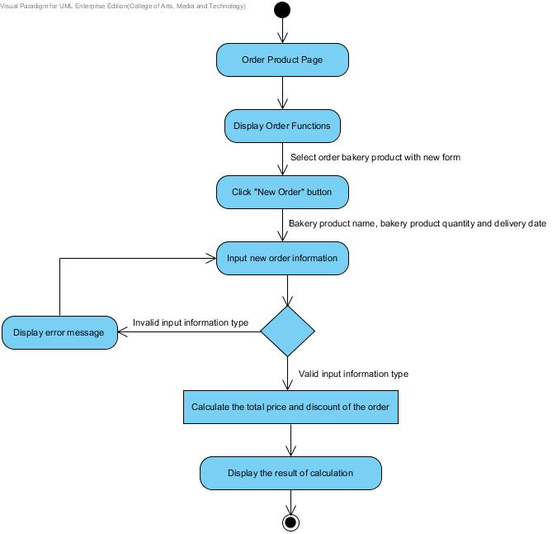**Action:**

**Figure 2: AD-12 Wholesaler order new bakery product**

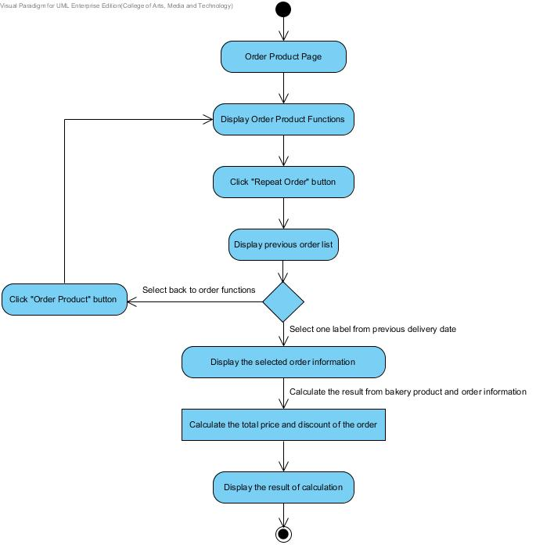

**Figure 3: AD-13 Wholesaler repeat a previous order information**

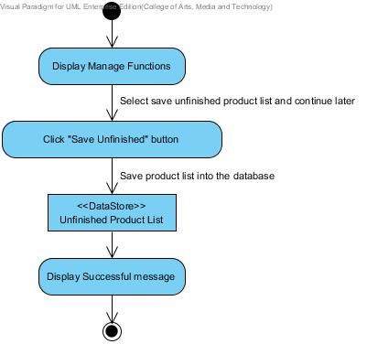

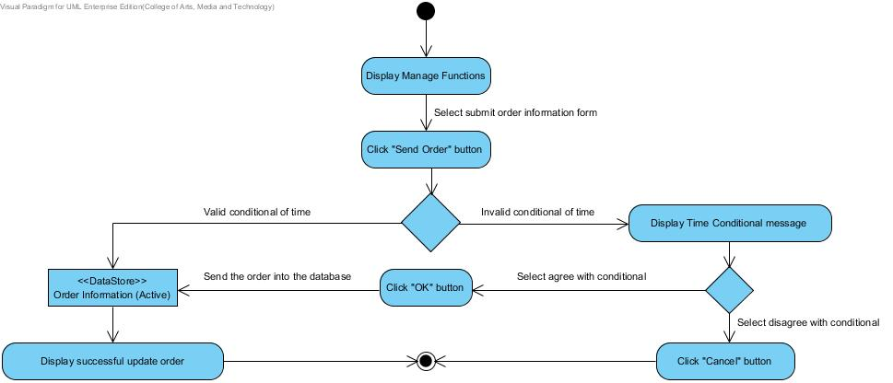**Figure 4: AD-14 Wholesaler save unfinished product list**

**Figure 5: AD-15 Wholesaler send order**

**Output:** Wholesaler can order all bakery products, and all order information will record to the database.

**System Requirement Specification:**

**SRS-38:** The system can connect to the phungnoi database and access User, webpages_Roles, Product, Order and OrderDetail tables.

**SRS-28:** The system shall provide a textbox in bakery product interface to search the bakery product information; bakery product ID, bakery product name, price and category in the database.

**SRS-39:** The system shall provide service for validation input information; bakery product ID, bakery product name, price and category with the existing bakery product information in the database.

**SRS-29:** The system shall provide a user interface to display all list of bakery product. In each label shall display bakery product name text and bakery product picture on bakery product list.

**SRS-30:** The system shall provide a user interface to display the existing bakery product information which are bakery product ID, bakery product name, product description, product price, product category and product picture on view information of bakery product page.

**SRS-40:** The system shall provide a link for ordering in the order product interface.

**SRS-41:** The system shall provide an order form in order product page for wholesaler input name of the bakery product, bakery product quantity and delivery date.

**SRS-42:** The system shall generate other information from input bakery name consist of bakery product ID, product price and product picture in each label of product list.

**SRS-43:** The system shall provide a calculating function to compute the total price and discount of each order.

**SRS-44:** The system shall provide a user interface to display the result of the total price and discount from all bakery product list.

**SRS-45:** The system shall provide button for sending finished order information in the order product interface.

**SRS-46:** The system shall provide button for repeating previous order information in the order history interface.

**SRS-47:** The system shall provide a user interface to display all list of the delivery date from previous order information. In each label shall display delivery date and total price on the order history list.

**SRS-48:** The system shall provide confirmation dialog box after delivery date link has been chosen.

**SRS-49:** The system shall provide a message to display a notification after the order form has been sent.

**SRS-50:** The system shall provide a link for saving unfinished product list in order product interface.

**SRS-06:** The system shall provide service to store information into the database.

**URS-08:** Wholesaler can manage own order information; bakery product name, bakery product quantity and delivery date in the order page.

**Precondition:** The wholesaler must has login to the system and current order information has been created.

**Input:**

|  |  |  |
| --- | --- | --- |
| **Name** | **Description** | **Example** |
| Bakery Product Name | The product name length must not be longer than 40 characters. Only alphabet is allowed. No special character can be used. | “Brownie” |
| Bakery Product Quantity | The amount of number to indicate bakery product order. | 1200 |
| Delivery Date | The date to check out and schedule for receiving bakery product’s order. | 17 October 2014 |

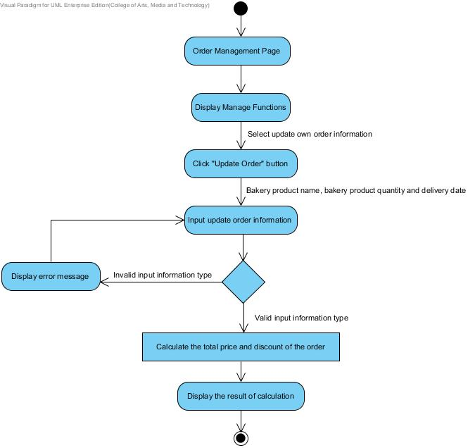**Action:**

**Figure 6: AD-16 Wholesaler update own order information**

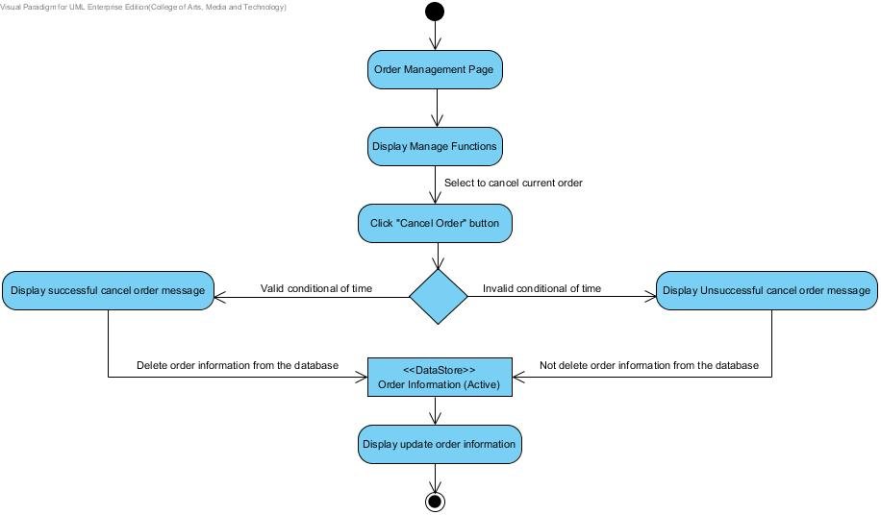

**Figure 7: AD-17 Wholesaler cancel own order**

**Output:** Wholesaler can manage own order information, and all updated information will record to the database.

**System Requirement Specification:**

**SRS-38:** The system can connect to the phungnoi database and access User, webpages_Roles, Product, Order and OrderDetail tables.

**SRS-28:** The system shall provide a textbox in bakery product interface to search the bakery product information; bakery product ID, bakery product name, price and category in the database.

**SRS-39:** The system shall provide service for validation input information; bakery product ID, bakery product name, price and category with the existing bakery product information in the database.

**SRS-29:** The system shall provide a user interface to display all list of bakery product. In each label shall display bakery product name text and bakery product picture on bakery product list.

**SRS-30:** The system shall provide a user interface to display the existing bakery product information which are bakery product ID, bakery product name, product description, product price, product category and product picture on view information of bakery product page.

**SRS-51:** The system shall provide a user interface to display current order’s information which are wholesaler name, bakery product ID, bakery product name, bakery product quantity and delivery date on view information of order management page.

**SRS-52:** The system shall provide a link for updating current order’s information in the order management interface.

**SRS-53:** The system shall provide an update form in order product page for wholesaler input name of the bakery product, bakery product quantity and delivery date.

**SRS-42:** The system shall generate other information from input bakery name consist of bakery product ID, product price and product picture in each label of product list.

**SRS-43:** The system shall provide a calculating function to compute the total price and discount of each order.

**SRS-44:** The system shall provide a user interface to display the result of the total price and discount from all bakery product list on view information of order management page.

**SRS-45:** The system shall provide button for sending finished order information in the order management interface.

**SRS-49:** The system shall provide a message to display a notification after the order form has been sent.

**SRS-54:** The system shall provide service to update order information into the database.

**SRS-55:** The system shall provide a link for deleting bakery product from order information in the order management interface.

**SRS-56:** The system shall provide confirmation dialog box after confirmation button has been chosen.

**SRS-57:** The system shall provide service to cancel order information into the database.

**SRS-58:** The system shall provide a message to display a notification after the order information has been deleted.

**URS-09:** Wholesaler can view their current order’s information; all list of bakery product name, bakery product quantity, price of each bakery product, the total price and discount of the order.

**Precondition:** The wholesaler must has login to the system.

**Input:** -

**Action:**

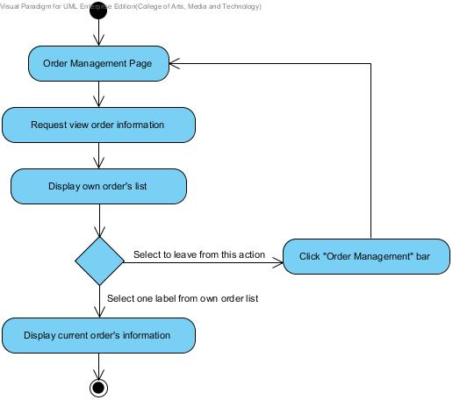

**Figure 8: AD-18 Wholesaler view own order information**

**Output:** Wholesaler can view current order information in the database.

**System Requirement Specification:**

**SRS-59:** The system can connect to the phungnoi database and access User, webpages_Roles and OrderDetail tables.

**SRS-60:** The system shall provide a link for view current order’s information in the view order information interface.

**SRS-52:** The system shall provide a user interface to display current order’s information which are wholesaler name, bakery product ID, bakery product name, bakery product quantity and delivery date on view information of order page.

**SRS-44:** The system shall provide a user interface to display the result of the total price and discount from all bakery product list on view information of order page.

**URS-10:** Admin can view current order’s information of all members by search keyword of wholesaler name, bakery product ID, bakery product name and delivery date in the database.

**Precondition:** The admin must has login to the system.

**Input:**

|  |  |  |
| --- | --- | --- |
| **Name** | **Description** | **Example** |
| Wholesaler Name | The wholesaler name should be the e-mail format. | “nontra@gmail.com” |
| Bakery Product ID | The number to indicate the product id. | 124658 |
| Bakery Product Name | The product name length must not be longer than 40 characters. Only alphabet is allowed. No special character can be used. | “Brownie” |
| Delivery Date | The date to check out and schedule for recieve bakery product’s order. | 17 October 2014 |

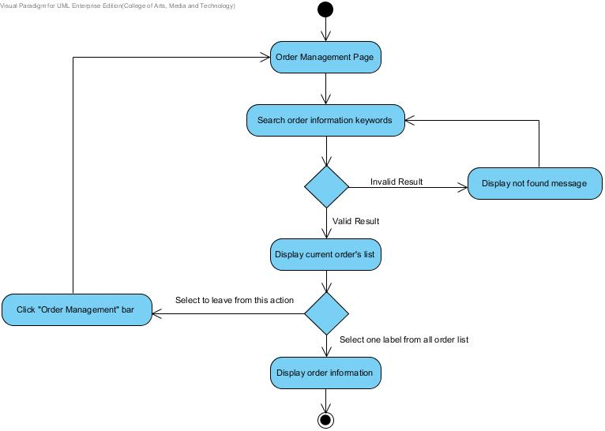**Action:**

**Figure 9: AD-19 Admin view all order information**

**Output:** Admin can view all order information in the database.

**System Requirement Specification:**

**SRS-01:** The system can connect to the database.

**SRS-53:** The system shall provide a textbox within order management interface to search the ordered information.

**SRS-04:** The system shall provide service for validation input information.

**SRS-54:** The system shall provide a user interface to display list of all ordered information. In each label shall display customer name text and delivery date on ordered information list.

**SRS-55:** The system shall provide a user interface to display the old ordered information which are customer name, bakery product ID, bakery product name, amount of each bakery product and delivery date on view information of order page.

**URS-11:** Admin can mark progressive of order status while the order in the preparation stage.

**Precondition:** The admin must has login to the system.

**Input:**

|  |  |  |
| --- | --- | --- |
| **Name** | **Description** | **Example** |
| Wholesaler Name | The wholesaler name should be the e-mail format. | “nontra@gmail.com” |
| Bakery Product ID | The number to indicate the product id. | 124658 |
| Bakery Product Name | The product name length must not be longer than 40 characters. Only alphabet is allowed. No special character can be used. | “Brownie” |
| Delivery Date | The date to check out and schedule for recieve bakery product’s order. | 17 October 2014 |
| Order Status | The order status display progress report while the order in the preparation stage | “Available” |

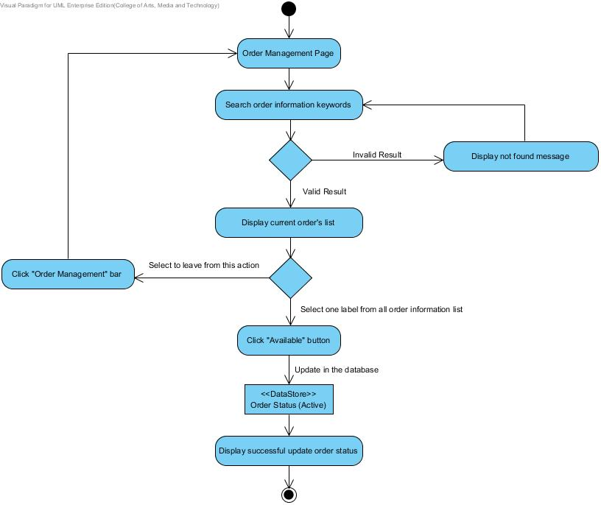**Action:**

**Figure 10: AD-20 Admin mark order status**

**Output:** Admin can mark available on order status and update information of order status will record to the database.

**System Requirement Specification:**

**SRS-59:** The system can connect to the phungnoi database and access User, webpages_Roles and OrderDetail tables.

**SRS-61:** The system shall provide a textbox in order management interface to search the order information; wholesaler ID, wholesaler name, bakery product ID, bakery product name and delivery date.

**SRS-62:** The system shall provide service for validation input information; wholesaler ID, wholesaler name, bakery product ID, bakery product name and delivery date with the existing order information in the database.

**SRS-63:** The system shall provide a user interface to display a list of all wholesaler who has current order’s information. In each label shall display wholesaler name text and delivery date on order information list.

**SRS-64:** The system shall provide button for marking progressive of order status in the order management interface.

**SRS-56:** The system shall provide confirmation dialog box after confirmation button has been chosen.

**SRS-65:** The system shall provide a message to display a notification after the order status in the preparation stage has been marked.

**SRS-06:** The system shall provide service to store information into the database.

**SRS-66:** The system shall provide service to update progressive of order status to display in order management interface.

**URS-12:** Wholesaler can view their progress order status while the order in the preparation stage.

**Precondition:** The wholesaler must has login to the system and order information has been submitted.

**Input:** -

**Action:**

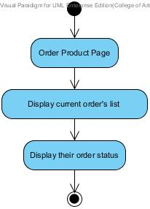

**Figure 11: AD-21 Wholesaler view their order status**

**Output:** Wholesaler can view their order status in the database.

**System Requirement Specification:**

**SRS-59:** The system can connect to the phungnoi database and access User, webpages_Roles and OrderDetail tables.

**SRS-51:** The system shall provide a user interface to display current order information which are wholesaler name, bakery product ID, bakery product name, bakery product quantity and delivery date on view information of order page.

**SRS-67:** The system shall provide a text to display the order status in their order page.

**URS-13:** Admin can manage all ingredient information; ingredient ID, ingredient name, ingredient description, category and ingredient picture in the database.

**Precondition:** The admin must has login to the system.

**Input:**

|  |  |  |
| --- | --- | --- |
| **Name** | **Description** | **Example** |
| Ingredient ID | The number indicate the ingredient id | 123456 |
| Ingredient Name | The ingredient name length must not be longer than 40 characters. Only alphabet is allowed. No special character can be used. | “Garlic” |
| Category | The category length must not be longer than 40 characters. Only alphabet is allowed. No special character can be used. | “Spices” |
| Ingredient Picture | The picture type of file must be PNG image. The size of picture is unlimited. | http://upload.wikimedia.org/wikipedia/commons/thumb/f/fb/Allium_sativum._Restra_de_allos_de_Oroso-_Galiza.jpg/1024px-Allium_sativum._Restra_de_allos_de_Oroso-_Galiza.jpg  Garlic.jpg |

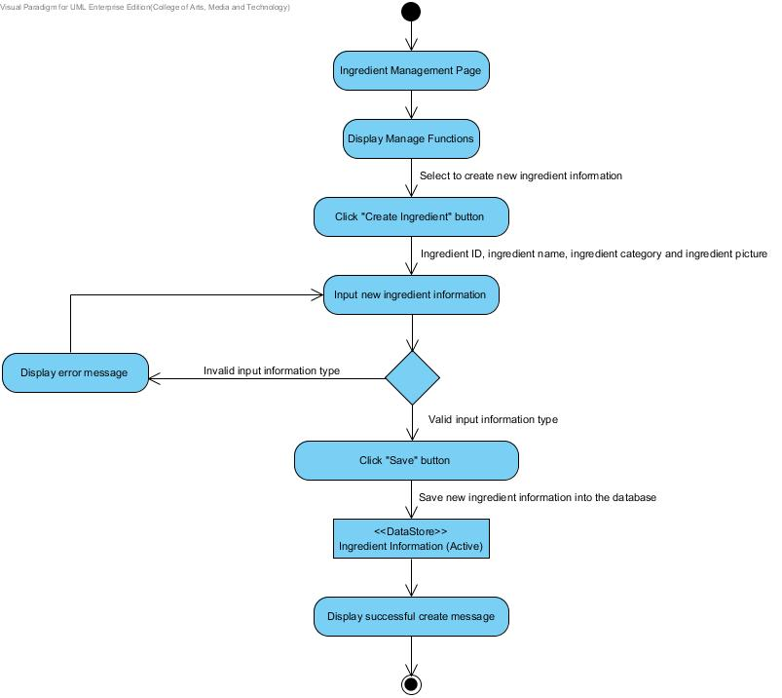**Action:**

**Figure 12: AD-22 Admin create ingredient information**

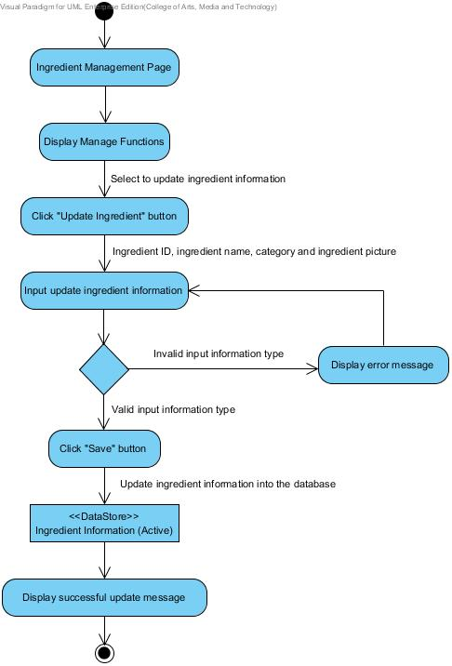

**Figure 13: AD-23 Admin update ingredient information**

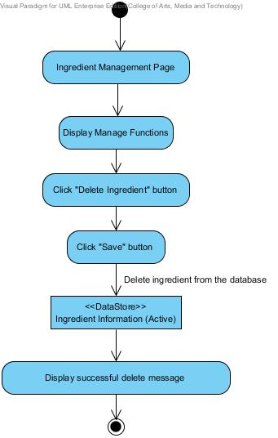

**Figure 14: AD-24 Admin delete ingredient information**

**Output:** Admin can manage bakery product information and all information of bakery product will record to the database and.

**System Requirement Specification:**

**SRS-68:** The system can connect to the phungnoi database and access User, webpages_Roles and Ingredient tables.

**SRS-69:** The system shall provide a link for creating new ingredient information in the ingredient interface.

**SRS-70:** The system shall provide an ingredient form in a create new ingredient information page for an admin input ingredient ID, ingredient name, category and ingredient picture.

**SRS-71:** The system shall provide service for validation input information; ingredient ID, ingredient name, category and ingredient picture.

**SRS-72:** The system shall provide a message to display a notification after the ingredient form has been sent.

**SRS-06:** The system shall provide service to store information into the database.

**SRS-73:** The system shall provide a textbox in ingredient interface to search the ingredient information; ingredient ID, ingredient name and category.

**SRS-74:** The system shall provide service for validation input information; ingredient ID, ingredient name and category with the existing ingredient information in the database.

**SRS-75:** The system shall provide a user interface to display all list of ingredient. In each label shall display ingredient name text and ingredient picture on an ingredient list.

**SRS-76:** The system shall provide a user interface to display the existing ingredient information which are ingredient ID, ingredient name, category and ingredient picture on view information of ingredient page.

**SRS-77:** The system shall provide a link for updating ingredient information in the ingredient interface.

**SRS-78:** The system shall provide an ingredient form in update ingredient information page for admin update new ingredient ID, ingredient name, category and ingredient picture.

**SRS-79:** The system shall provide service to update ingredient information into the database.

**SRS-80:** The system shall provide a link for deleting ingredient information in the ingredient interface.

**SRS-56:** The system shall provide confirmation dialog box after confirmation button has been chosen.

**SRS-81:** The system shall provide service to delete ingredient information into the database

**SRS-82:** The system shall provide a message to display a notification after the ingredient information has been deleted.

**URS-14:** Admin can view all ingredient information by search keyword of ingredient ID, ingredient name and category in the database.

**Precondition:** The admin must has login to the system and the ingredient information has been created in the system.

**Input:**

|  |  |  |
| --- | --- | --- |
| **Name** | **Description** | **Example** |
| Ingredient ID | The number indicate the ingredient id | 123456 |
| Ingredient Name | The ingredient name length must not be longer than 40 characters. Only alphabet is allowed. No special character can be used. | “Garlic” |
| Category | The category length must not be longer than 40 characters. Only alphabet is allowed. No special character can be used. | “Spices” |

**Action:**

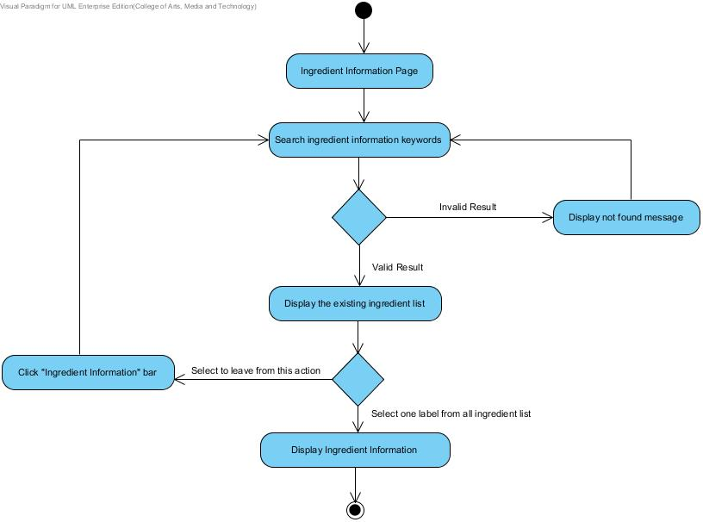

**Figure 15: AD-25 Admin view ingredient information**

**Output:** Admin can view all ingredient information in the database.

**System Requirement Specification:**

**SRS-68:** The system can connect to the phungnoi database and access User, webpages_Roles and Ingredient tables.

**SRS-73:** The system shall provide a textbox in ingredient interface to search the ingredient information; ingredient ID, ingredient name and category.

**SRS-74:** The system shall provide service for validation input information; ingredient ID, ingredient name and category with the existing ingredient information in the database.

**SRS-75:** The system shall provide a user interface to display all list of ingredient. In each label shall display ingredient name text and ingredient picture on an ingredient list.

**SRS-76:** The system shall provide a user interface to display the existing ingredient information which are ingredient ID, ingredient name, category and ingredient picture on view information of ingredient page.